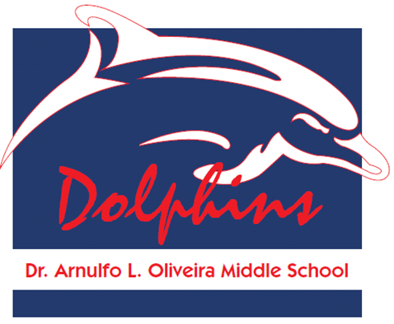
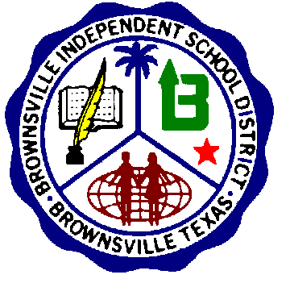
BROWNSVILLE INDEPENDENT SCHOOL DISTRICT
TITLE I PARENTAL INVOLVEMENT POLICY
Oliveira Middle School
2012-2013

I. STATEMENT OF PURPOSE

Oliveira Middle School is committed to providing quality education to every student in the district. Partnerships with parents and the community are essential to this goal as neither home nor school can achieve this goal independently. Everyone gains if school and home work together to promote high student achievement. Parents play an important role as children’s first teacher and their support is critical to their children’s success. Oliveira Middle School intends to include parents in all aspects of the district’s Title I programs to create a school-home partnership that will promote student success.
Grade level goals for all children in Oliveira Middle School will be distributed to parents with the expectation that all students will work toward these goals. Oliveira Middle School recognizes that some students may need the extra assistance of Title I programs to reach these goals and is committed to providing that support.

- After School Tutorials
- Saturday Academy
- STAAR Tutorial
- Counseling Sessions
- Family Centers
- Computer Lab
- Library
- Math and Science Enrichment

II. PARENTAL INVOLVEMENT IN DEVELOPING AND REVISING THE POLICY

The Oliveira Middle School Advisory Committee consisting of campus parents, teachers, principal and community members developed the campus Parental Involvement Policy. Oliveira Middle School will annually form an Advisory Committee to review the campus Parental Involvement Policy and to revise it as necessary. Special attention will be given to recruiting parent volunteers of children served in the Title programs, with a goal of having at least three parents on the committee.

● September 2012
● November 2012, March 2013

III. ANNUAL TITLE I CAMPUS PARENT MEETINGS

Oliveira Middle School will hold an annual Title I meeting for parents. These meetings will be held during the fall semester. The purpose of these meetings is to provide parents with information regarding Title I guidelines and services offered to students utilizing Title I funds as stated in the current campus Parental Involvement Policy. The Parental Involvement Policy will also be distributed to parents. Parents will be given the opportunity to offer their suggestions for any revisions to the policy at a set meeting. Parents may also volunteer to serve on the district-wide and/or school’s advisory committee.

The annual meeting will be held at flexible times to increase the opportunity for parental participation. English and Spanish translation will be available. Written notices in both languages will be sent to parents notifying them of the date and times of the meetings. Parent volunteers, parent trainers, and parent liaisons will also contact other parents by phone regarding the meetings. Volunteers who speak both English and Spanish will make all contacts.

● Title I Meeting held on October 02, 2012

IV. SCHOOL-PARENT COMPACT

According to Title I regulations, Oliveira Middle School must share responsibility with parents for high student achievement by jointly developing a school-parent-student compact. These compacts must outline the responsibilities of parents, staff, and students for promoting high student performance. Parents on Oliveira Middle School Advisory Committee will be involved in designing and reviewing the compact. Students’ responsibilities may vary by grade level.
All parents will receive the compact from their child’s school with a checklist of the responsibilities that teachers, parents, and students have for helping students achieve their goals.
Parents are urged to discuss the compact with their children before they and their children sign the document.

● September 2012
● Review March 2013
● Review and update spring 2013

V. TYPES OF PARENTAL INVOLVEMENT

Oliveira Middle School will provide opportunities for parent engagement to become involved in their children’s education. Oliveira Middle School values both the at-home contributions of parents and those that take place at the school or in the community. Reading to children at home and talking with them at family meals are as important as volunteering at school and serving on advisory committees. Many types of parental involvement are needed in school-home-community partnership to help all children succeed. In alignment with BISD’s philosophy and mission, the Oliveira Middle School Campus Improvement Plan (CIP) includes a parental involvement component. All parent and community volunteers must comply with the district policy regarding State of Texas background checks.

- Weekly Parent Meetings
- Cluster Meetings
- Parenting Skills Classes
- CATCH/ FIT Program
- Meetings with different community agencies

VI. ADAPT PROGRAMS TO THE NEEDS OF OUR COMMUNITY

Each year Oliveira Middle School will assess the needs of parents and children in the community through a variety of measures, including questionnaires sent home to parents, so that Title I programs can be tailored to meet those needs. Workshops and other programs will be available to address the expressed needs. Parents will be notified of these opportunities by the individual schools.
Parents may also call the Parental Involvement Department to express an interest in a particular workshop topic or to make recommendations about the program.

● Surveys will be conducted at beginning and end of 2012-2013 School Year

VII. STAFF-PARENT COMMUNICATION

Communication with parents may include a school newsletter distributed by each school at least four times a year. Notices and activity packets sent home with children, telephone calls, conferences, and home visits will promote school-home communication as well. Notices sent home should be in both English and Spanish. Parents are encouraged to take the initiative in calling their child’s teacher or campus administrator when they have a concern. Staff should receive training on techniques to improve home-school communication. Parents may participate in this training.

- Phone Calls
- Monthly Calendar Activities
- Fliers
- Marquee Announcements
- School Messenger

VIII. EVALUATION

The campus Advisory Committee, which may include parents of Title I, Migrant, Bilingual, Special Needs and GT students, will participate in the process of school review and improvement. This committee will collect information in a variety of ways, including campus visits and class observations.
Parents will also be asked for their input on the content and effectiveness of the campus Title I parental involvement program through an annual evaluation of the program. The evaluation will include an assessment of overall increases in parental involvement and barriers to parental participation that still need to be overcome. Oliveira Middle School will revise its campus Parental Involvement Policy and Campus Improvement Plan on the basis of this annual review.

● Spring 2013 District Wide

